Lecture 2

Resistive Network Analysis

Learning Objectives:
- Compute solutions to circuits using Node Analysis.
- Compute solutions to circuits using Mesh Analysis.

Node-Voltage Analysis

It is the most general method for the analysis of electric circuits. This method is based on defining the voltage (with respect to one node chosen as the reference node whose voltage is taken as zero) at each node as an independent variable. Then, each branch current is expressed in terms of one or more node voltages. Once current in each branch is defined in terms of the node voltages, Kirchoff’s current law is applied at each node except at the reference node.
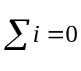
For a circuit with N nodes, this results in a set of (N-1) linear equations.

Steps of Node Voltage Analysis method

- Select a reference node (Usually the ground). This node usually has the most elements connected to it.
- Define the remaining (n-1) node voltages as the independent or dependent variables. Each of the m voltages sources in the circuit is associated with a dependent variable. If a node is not connected to a voltage source, then its voltage is treated as an independent variable.
- Apply KCL at each node labeled as an independent variable, expressing each current in terms of the adjacent node voltages.
- Solve the linear system of n-1-m unknowns.

Analysis with controlled sources

Such situations arise in study of transistor amplifiers.

Method for handling such situations:
- Treat it as an ideal source and write the equations as before.
- Then use the constraint equations (which relates the dependent source to one of the other voltage and currents) to substitute the controlled source.
- The number of unknowns stays unchanged even after the substitution of controlled source.

Case: Node analysis with one source and resistors
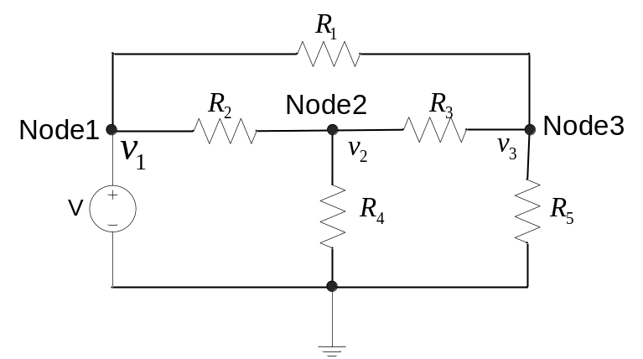
Fig. 1 Simple case of node analysis

Selecting the reference node

Any node can be taken as the reference node. However, the node with maximum number of elements connected to it or the negative end of a voltage source is taken as the reference node.

Assigning node voltages

Label the node voltages as 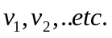 which are with respect to the reference node.

Writing KCL equations in terms of the node voltages

We need as many independent equations as the number of unknowns. These are obtained by applying KCL at each node.

KCL states that the sum of currents leaving a node is equal to zero.

To find the current leaving the node n through each resistor connected to the node k, we subtract the voltage at node k from the voltage at node n and divide the difference by the resistance.

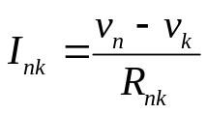
Applying KCL at node 2,
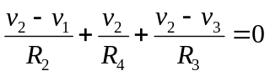 (1)
Applying KCL at node 3, sum of currents leaving the node equals zero.
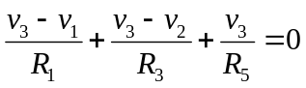 (2)

At node 1, we cannot apply KCL as not all branches connected to this node are resistors. We cannot find the current through a voltage source by applying the same method that we used to find the current through a resistor.

However, we can write anther independent equation by equating the node voltage to that of the voltage source.
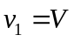 (3)

Case 2: Having an ideal current source between two nodes.

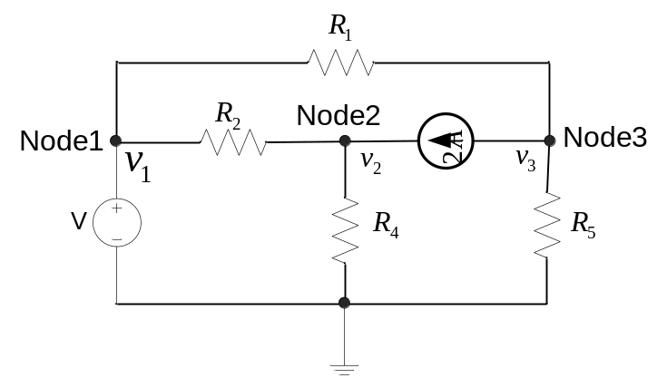

Applying KCL at node 2 (sum of currents leaving node2 equals zero), current going from node2 to node3 is -2A.

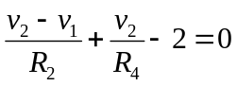 (1)
Applying KCL at node 3, sum of currents leaving the node equals zero.
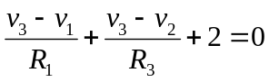 (2)

Circuits with controlled sources

When there are controlled elements in the circuit, the equations are written following the same procedure as with independent source, using the values of the controlled sources.

Then, the values of the controlling variables are replaced in terms of the node voltages

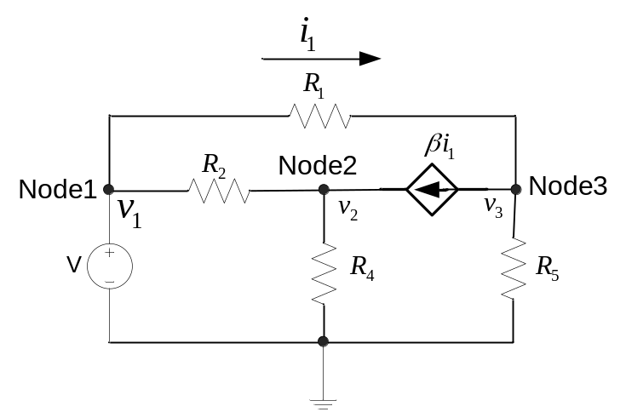

Applying KCL at node 2 (sum of currents leaving node2 equals zero), current going from node2 to node3 is 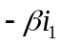.

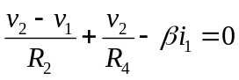 (1)
We have to next replace the current 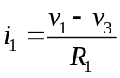 in above equation to get the equation in terms of the node voltages as desired:
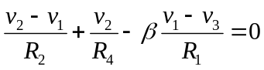 (1)

This way, we end up having the all the independent equations in terms of the node voltage variables.

Case 3: Having an ideal voltage source connected between two nodes.

As shown in the Figure 2, If a voltage source is connected between two nodes (node1 and node2), neither of which is the reference node.

Again, as we cannot express the current through the voltage source in terms of the node voltages, we cannot write the usual KCL at these two nodes.
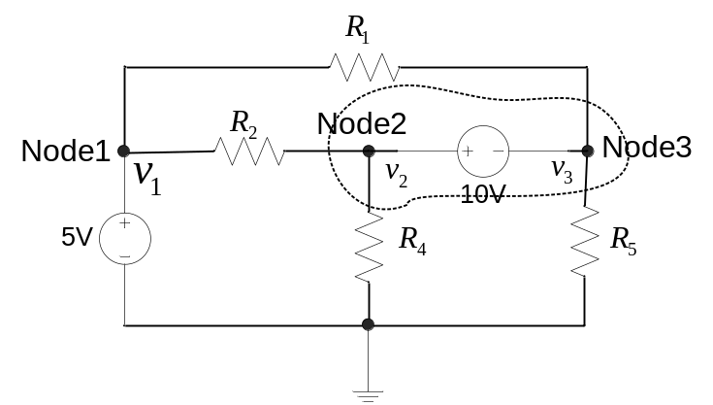
Fig. 2 Case with a voltage source between two nodes

To solve this problem, we identify a super node (marked by the dotted line) around the voltage source as shown in Figure 2. We can then find the currents in the branches (R1, R2, R4, R5) associated with the super node in terms of the node voltage variables. We can apply the KCL to the super node to find one independent equation. Note that for the two nodes, we can write only one independent equation.

The KCL equation will be,
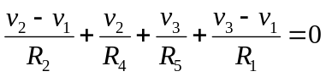 (1)

What will be the three independent equations then?

We can write the following equation for node1 voltage:
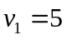 (1)

For the nodes connected by the voltage source, we can take care of the voltage polarity and write:
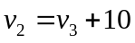 (2)

With the three independent equations we can solve for the three unknowns.

The mesh current analysis method

The mesh current method employs mesh currents as the independent variables. From the mesh currents, the current and voltage for each branch is obtained using Ohm’s law. Subsequent application of Kirchoff’s voltage law around each mesh provides the desired system of equations.

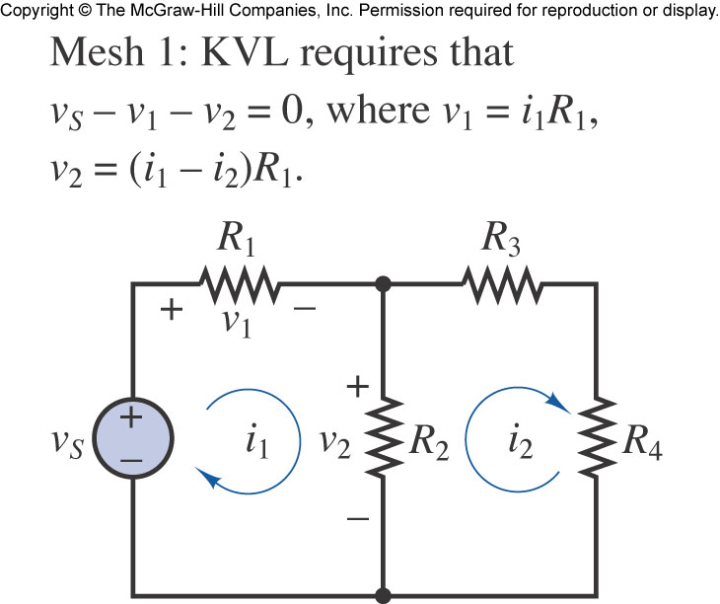

Branch current -> branch voltage

Steps of mesh current analysis

- Define each mesh current consistently. Unknown mesh currents will be always defined in the clockwise direction; known mesh currents (i.e. when a current source is present) will always be defined in the direction of the current source.
- In a circuit with n meshes and m current sources, n-m independent equations will result. The unknown mesh currents are the n-m independent variables.
- Apply KVL to each mesh containing an unknown mesh current, expressing each voltage in terms of one or more mesh currents.
- Solve the linear system of n-m unknowns.

Example: To find the voltages and currents for all the resistances in the circuit.

Simple case:

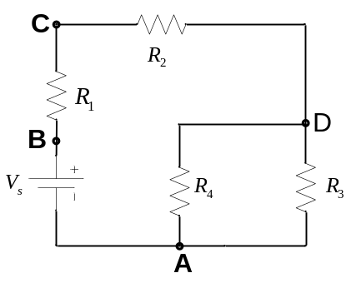
Fig. Given circuit to be solved
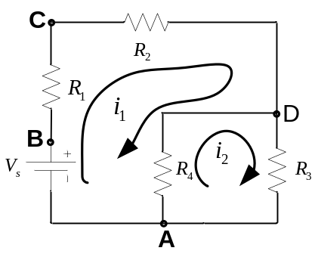

Fig. Identifying the mesh currents

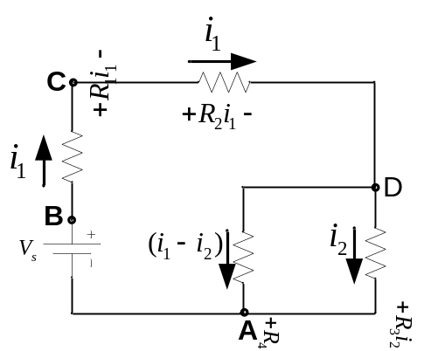

Fig. Assigning the branch currents in terms of the mesh currents.

Applying the KVL to the meshes, one can get:
For mesh ABCDA, sum of voltage rises:
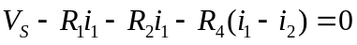 (Loop1)

For mesh ADA, sum of voltage rises:
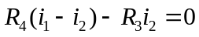 (Loop2)

Rearranging the terms we get two independent equations:
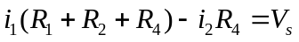
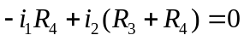

Solving the two equations above, one can get:
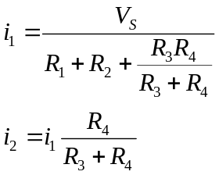
Using the two mesh currents, we can find the current and voltages associated with all the resistors in the circuit.

Case : With a voltage source in one of the branches

Suppose there were an extra voltage source between in D and D’ as given in the Figure.
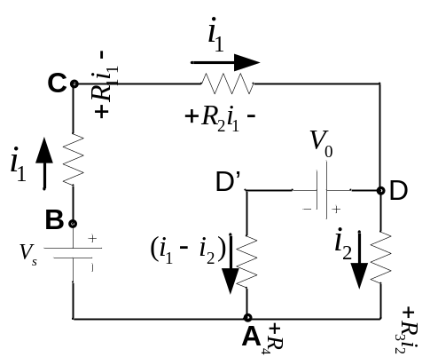

Applying the KVL to the meshes, one can get:
For mesh ABCDD’A, sum of voltage rises:
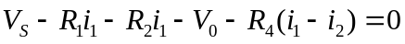 (Loop1)

For mesh ADD’A, sum of voltage rises:
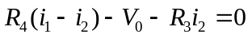 (Loop2)

Case : with a current source in one of the branches.

Suppose there was a current source between in D and D’ as given in the Figure.

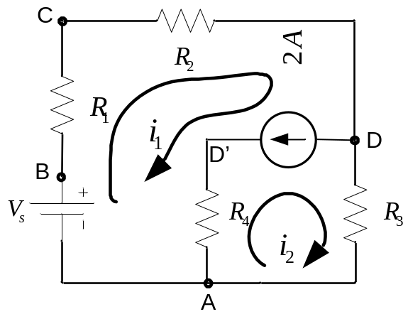

To apply the KVL to the mesh ABCDD’A , we need the voltage across the current source (between DD’). However, unlike a resistor, we cannot express the voltage across the current source in terms of the mesh currents.
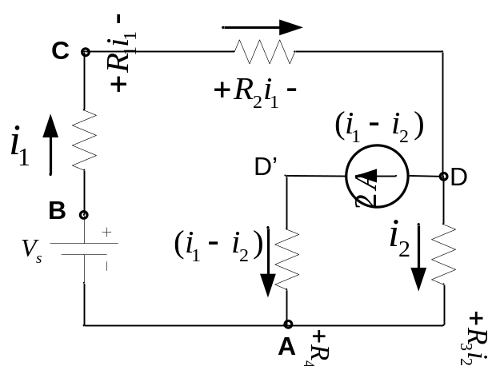
This problem is solved by applying KVL for the loop ABCDA. Sum of voltage rises around this loop:

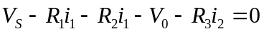 (Equation 1)

We need to get another independent equation for solving the system.

As can be seen from the figure, 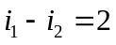 (Equation 2)

We can solve for both the mesh currents and determine the voltage and current in all the parts of the circuit.

Case: mesh analysis with controlled sources
Such situations arise in study of transistor amplifiers.

Method for handling such situations:
- Treat it as an ideal source and write the equations as before.
- Then use the constraint equations (which relates the dependent source to one of the other voltage and currents) to substitute the controlled source.
- The number of unknowns stays unchanged even after the substitution of controlled source.

Example: To find the output voltage 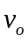.
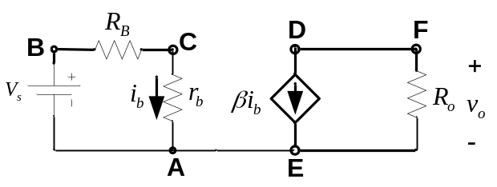

Identifying the mesh currents.
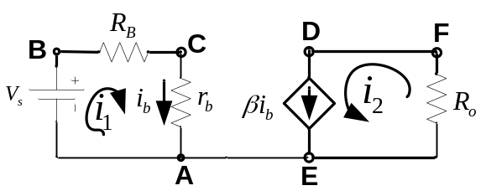
Finding the branch currents and voltages in terms of the mesh currents.
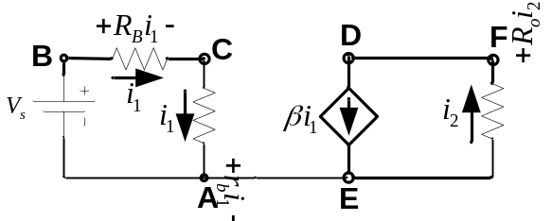

Applying KVL to mesh1 (ABCA), adding sum of voltage drops:
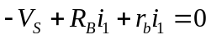
This gives: 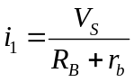

From mesh2(DEFD), it is clear that
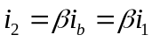

It is important to note that mesh2 cannot be used by applying KVL to it and obtain the second independent equation. This is because, unlike a resistor for which we can find the voltage across it in terms of the current, we cannot always find the voltage across it.

However, we can find the mesh2 current in terms of the current of this current source. This is the other independent equation.

Using these two equations, the two mesh currents can be solved.

Finally, 

